Homework for the week of November 11, 2013; due Monday November 18, except journal entries, which are due Tuesday, November 19th, with divi lights and coupon payments.

1. What does Sub-Saharan Africa mean?___________________________________________________

2. Name and label four Sub-Saharan African countries including Uganda, on the map below:
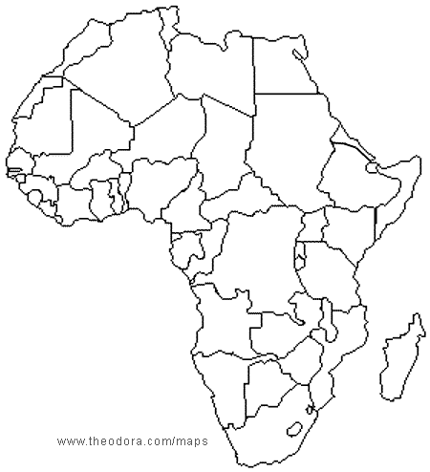

- Is Africa a continent or a country? _______________________________________________
- Name all of the continents that you know (continents begin with capital letters!):

_______________________________________________________________________________________________

_______________________________________________________________________________________________

_______________________________________________________________________________________________

3. Define the following words on a separate sheet of paper:

- Rural
- Poverty
- Illiteracy
- Credit
- Income
- Off-grid or off-the-grid

4. Tally and count the light bulbs inside and outside your home (including your bedroom)

Tally | Total

- How many light bulbs in your bedroom alone?

- Watch the 19 minute long film on life in rural Uganda on the Arlington Academy of Hope website. Invite your family to watch with you.
http://aahuganda.org/watch/

There is a link on our class website as well.

Use your light. Write three separate journal entries in your take home journal.

Each journal entry should be one full page.

Journal entries are due on Tuesday, November 19, 2013 with your next micro-credit payment. Don’t forget your light.

- How did you use your light and what did you notice? How was it different from your normal lighting? Give details. Tell your story.

- What are your impressions from the film about life in Uganda? How is life different than your life in Boulder, Colorado? What surprised you?

- Write a faux diary entry in “first person” person about the life of a Ugandan based upon the film that you watched OR write a poem. Maybe even try a poem for two voices.

Ideas for using your divi light:

- Do your homework using only your divi light.
- Eat a family meal using only your divi light
- Cook using only your divi light
- Read using only your divi light
- Have a family conversation or play a game using only your divi light
- Take a walk outside using only your divi light
- Hunt for snakes and scorpions in your home using only your divi light
- See how much area is illuminated in a room using only your divi light versus your normal light
- Take a bath using only your divi light. Well, and some water.
- What other nighttime experiences would be different in your life if you had no electricity?

