This week for homework, you will have four tasks to complete, plus reading:
- Type any outstanding rough draft work (book reviews, artist statements, color poems) and share them with me as a Google Doc. Due Wednesday
- Draw and complete a plan for your aluminum foil vessel using what you know about buoyancy and displacement. DUE Friday morning.
- Complete part 1 of time management homework. DUE Tuesday, October 14
- One journal entry that shows writing from the heart and author’s craft. Due on your regular journal day

Time Management Homework - Part one
Between now and conference week (Oct. 29-31) we will examine time management and homework habits. Please complete the following for your time management homework this week:

Read and review the PBS kids page about time management. Read the first two pages: You vs. The Clock; Have to’s, Want to’s and Goals.

- Complete the survey you find here
- Create a Google Doc titled Melvin’s Time Management (or your name if it is not Melvin) Share the Google Doc with me.
- Address the following on your Google Doc:
- Make a plan to review your planner with a parent each week. Describe your plan on the Google Doc. Use full sentences.
- What is your plan for making sure that your planner and school supplies get to school each day? Discuss this with your family and make a plan. Maybe you put your things in a backpack the night before, maybe you have a checklist that you’ll use in the morning. Write your plan on your Google Doc.
- Make a personal list of your Have to’s, Want to’s and Goals. A description of these things are found here. Include your list on your Google Doc.

or instead of a Google Doc,

You can create a mind map in color including all of the things that would have been included in your Google Doc. Click Mind mapping for more information on mind mapping. Your mind map should include pictures & words & color.

Next week, we’ll make a ‘budget, a color coded weekly schedule and a sketch of where you do your homework. During the third week, we’ll examine time tips and time wasters, set some goals, and reflect.

Your plan for a winning boat!!!
On Friday, we’ll have an aluminum boat challenge to see who can create a vessel that holds the most penny passengers. Popsicles will be awarded to the winner. And all the losers. Sketch your boat design and state three reasons why you think it will have a large carrying capacity. You can choose to include measurements. Try to use the following words or some form of the following words: buoyancy, force, displacement, capacity. You can practice making a boat at home in the kitchen sink, while your mom is trying to make dinner. She’ll like that. You will have 1 sheet of aluminum foil measuring exactly 30 x 45 centimeters.
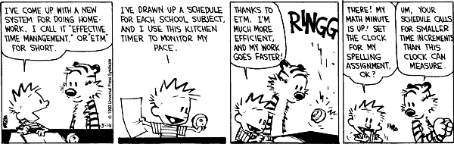

I told you there was a Calvin and Hobbes for every topic.

